Parameter Estimates (10 Imputations)
Parameter | Estimate | Std Error | 95% Confidence Limits |  | DF | Minimum | Maximum | Theta0 | t for H0:  Parameter=Theta0 | Pr > |t|
Intercept | 48.389456 | 4.046962 | 40.45564 | 56.32327 | 5009.1 | 47.118096 | 49.513229 | 0 | 11.96 | <.0001
PPVTZ | 0.239636 | 0.029636 | 0.18061 | 0.29866 | 75.861 | 0.219703 | 0.279547 | 0 | 8.09 | <.0001
recogz | 0.295103 | 0.038998 | 0.21858 | 0.37163 | 1036.3 | 0.271962 | 0.316102 | 0 | 7.57 | <.0001

residual
Parameter Estimates (10 Imputations)
Parameter | Estimate | Std Error | 95% Confidence Limits |  | DF | Minimum | Maximum | Theta0 | t for H0:  Parameter=Theta0 | Pr > |t|
Estimate | 71.749440 | 5.017627 | 61.86121 | 81.63767 | 222.18 | 66.980869 | 75.394443 | 0 | 14.30 | <.0001

UN(1,1)
Parameter Estimates (10 Imputations)
Parameter | Estimate | Std Error | 95% Confidence Limits |  | DF | Minimum | Maximum | Theta0 | t for H0:  Parameter=Theta0 | Pr > |t|
Estimate | 581.337933 | 249.163334 | 92.92052 | 1069.755 | 8923 | 522.428402 | 648.850340 | 0 | 2.33 | 0.0197

UN(2,2)
Parameter Estimates (10 Imputations)
Parameter | Estimate | Std Error | 95% Confidence Limits |  | DF | Minimum | Maximum | Theta0 | t for H0:  Parameter=Theta0 | Pr > |t|
Estimate | 0.049586 | 0.021204 | 0.008023 | 0.091150 | 11722 | 0.043490 | 0.054583 | 0 | 2.34 | 0.0194

UN(2,1)
Parameter Estimates (10 Imputations)
Parameter | Estimate | Std Error | 95% Confidence Limits |  | DF | Minimum | Maximum | Theta0 | t for H0:  Parameter=Theta0 | Pr > |t|
Estimate | -5.229157 | 2.289637 | -9.71728 | -0.74104 | 10624 | -5.809743 | -4.636036 | 0 | -2.28 | 0.0224

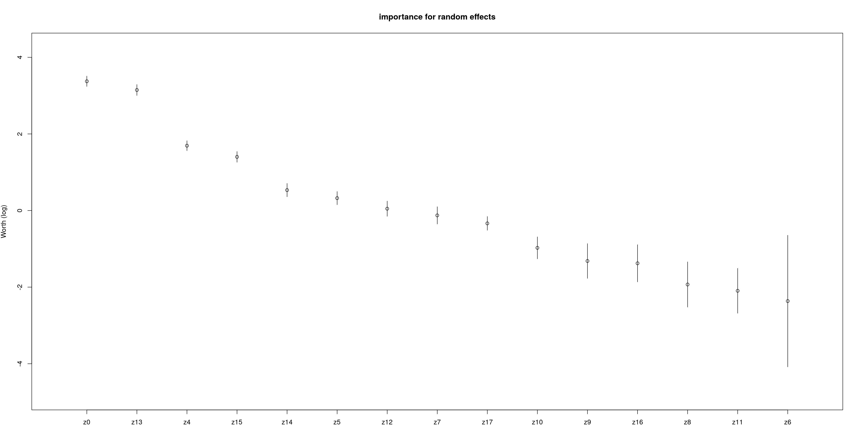

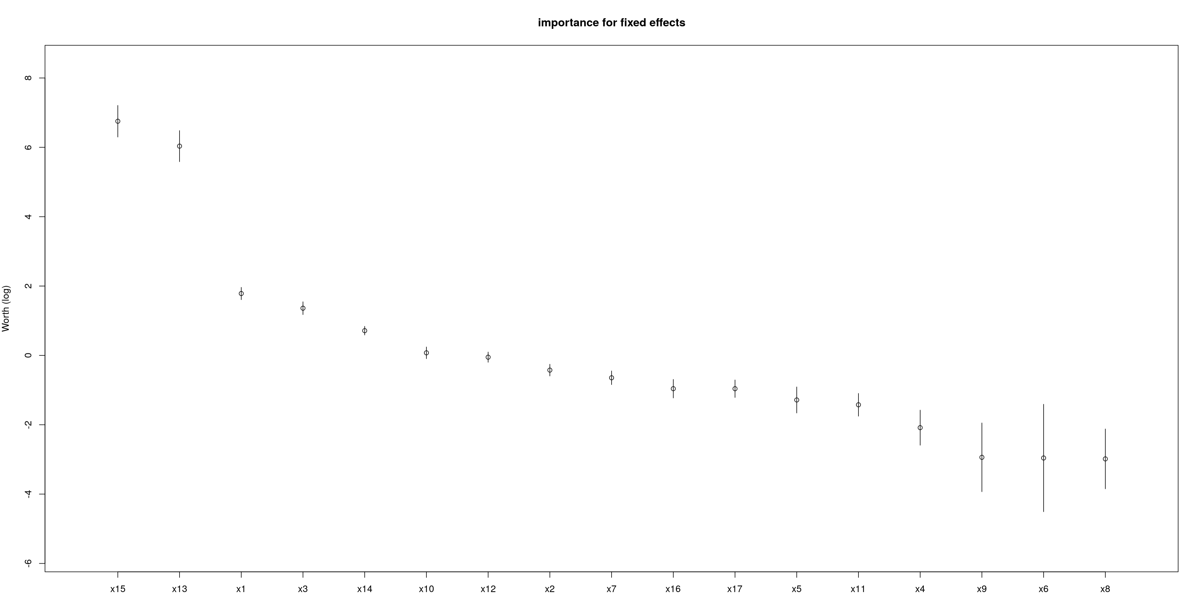

Variable labels | Variable name |  | Variable names
Z0 | Intercept | X9, Z9 | BPI (behavior problems index)
X1 | Mom's age at birth of child | X10, Z10 | SPPCS (self-perception profile: scholastic)
X2 | Child gender | X11, Z11 | SPPCG (self-perception profile: self-worth)
X3 | Mother’s Education | X12, Z12 | DIGIT (Digit span)
X4, Z4 | House size | X13, Z13 | RECOG (reading recognition)
X5, Z5 | Weight of the child | X14, Z14 | COMP (reading comprehension)
X6, Z6 | Height of the child | X15, Z15 | PPVT (vocabulary test score)
X7, Z7 | COGNZ (cognitive stimulation in home) | X16, Z16 | Time spent on homework
X8, Z8 | EMOTZ (emotional support in home) | X17, Z17 | wave

